**Feedback & Suggestions on the mentioned website as Functional Quality Engineer & as an EndUser**

**Functionality**

* Name Fields like First Name, Middle Name and Last Name accepts all Letters, Dot and Space. So on giving input like ‘M<SPACE>‘ it accepts, Which is not a valid name.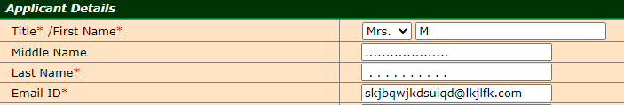
* Email ID is accepting input that contains ‘@’ and ‘.com’. For example [abcdef@hijkl.com](mailto:abcdef@hijkl.com) but validation is done, whereas Aadhar number is validated immediately. 
* On selecting solar connection type, Upload Required Documents mentions the file format and maximum size limit of the file. It is missing for the other two connection types.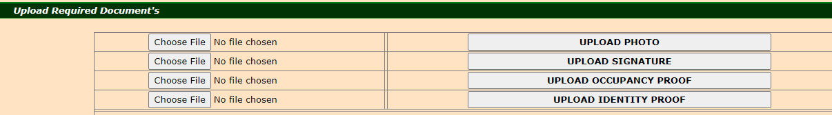
* Declaration mentioned in connection details doesn’t show link to Terms and Conditions Document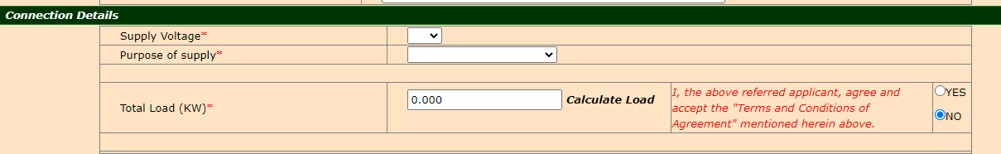
* View photo here and view signature here are present in the same grid but should be present in two grids.

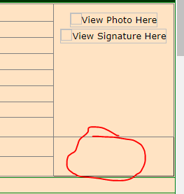

* Even if other Required Fields are not filled except supply Voltage, Load Calculator calculates Load.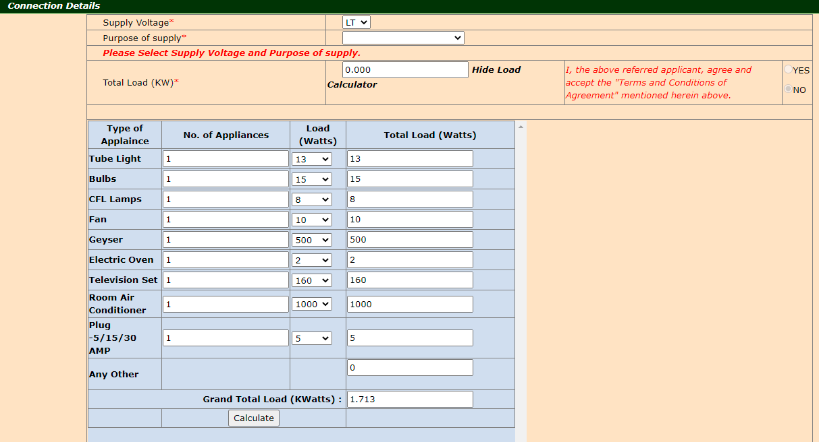
* In the Load calculator, Any other field is taking input with many digits which should be restricted to certain digits based on the requirement.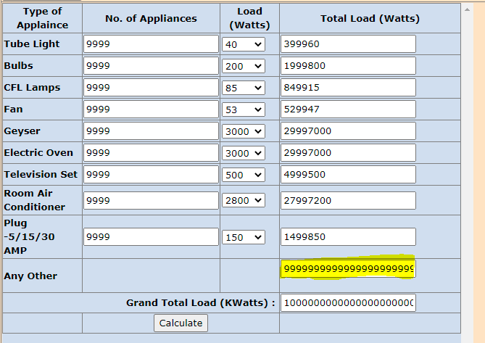
* On Clicking Reset All button, No Radio button is selected as Default in connection type section whereas remaining radio buttons in the form are set to default values.
* In Solar Connection type, Upload Required Documents, on clicking ‘Download Prior intimation for Installation form’ link Error 404: Page not found is loaded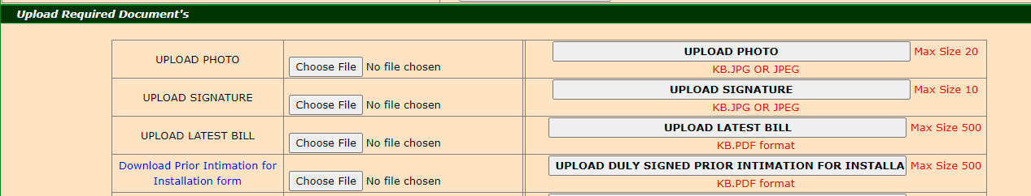

**Usability**

* Link to make payment should be clear to the user.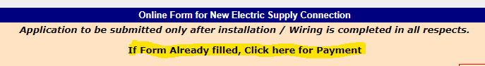
* Load calculator can be a popup, without changing the homepage appearance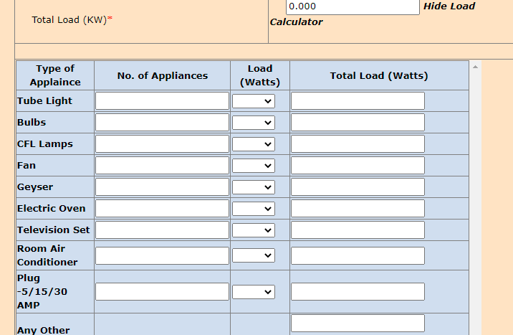
* Aadhar card number has spaces in original aadhar card but this input field only takes 12 characters, with no spaces or - symbol.
* Instead of displaying all categories of inputs, by default Applicant details should be visible. Other containers should be minimized. On completion of one section, users should be taken to the next section.
* Declaration is present twice on the page which is usually done only once.
* Generate OTP should have an information message to inform customers that otp will be sent to the phone number provided in the Applicant details section. It should also inform about the duration for which the otp is valid.

**UI Aesthetics**

* Color used for section Select connection type is not used anywhere else.
* All the number fields label name should be ‘No.’ but No is mentioned on every label name except for Plot Number and Building Number.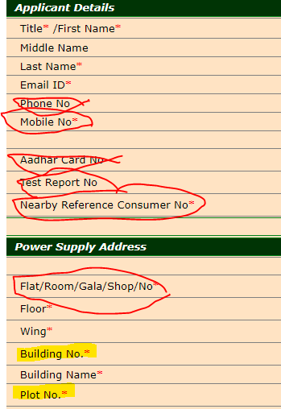
* No Sync in Input Fields. Input textboxes , as per functionality, don't accept the same input size but they appear the same size on the UI. Also not all input text boxes look the same in the later section.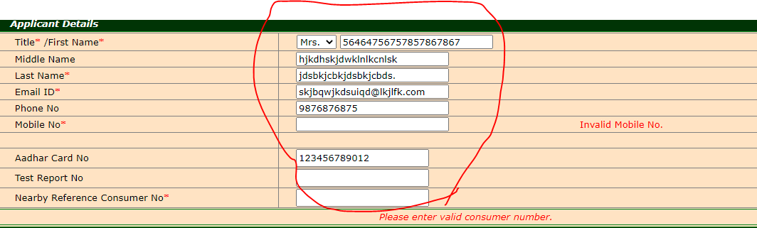
* Warning messages are not displayed in Sync with each other.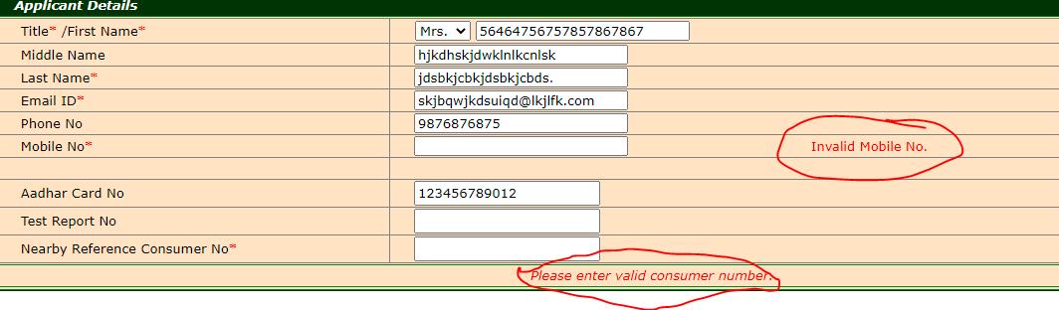
* Text Against the Radio buttons should have proper Padding.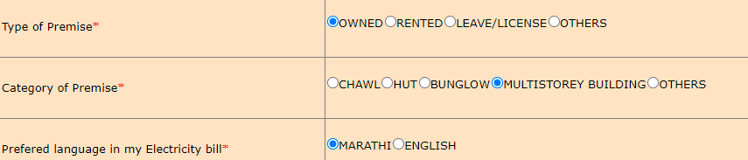
* Calculate load doesn’t appear like a Button or Link.
* In Billing address PIN label should be PIN Code.
* Option Yes is in camel case while Option NO is all caps.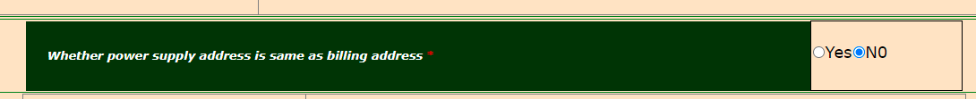
* Alignment of the Page Grid till Power Supply Address Grid and Alignment of the Page Grid from Billing Address Grid are not Synchronised, ie Grids on the upper part occupies the whole width of the page whereas grids on the lower part are center aligned.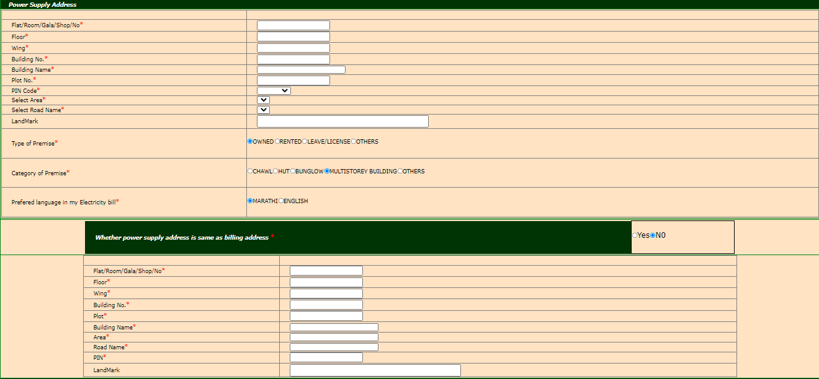
* Billing Address Header is missing.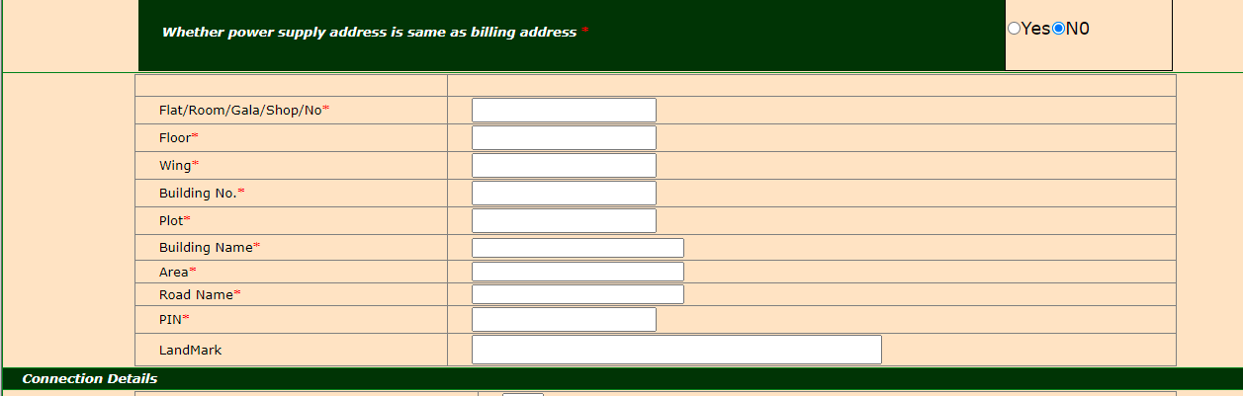
* Grid Alignment can be improved by aligning grid objects properly which improves the GUI appearance.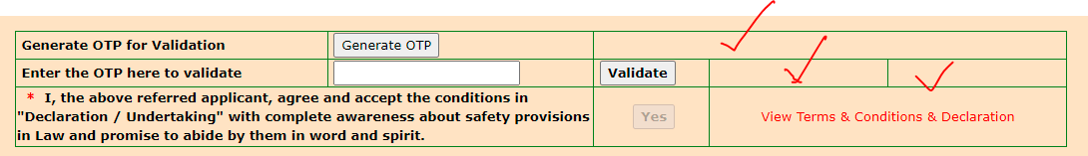
* Upload Required Documents Header has an apostrophe which is not correct.